Andrew Sheffield

Avi Dey

Gianna Fusaro

Roert Buser

**List Ninja Written Conceptual Design**

**List Of Major Features**

* **Easily keep track of multiple lists with different people**
* **Keep track of who is purchasing what items**
* **Manage expenses within the group**

**Major Modules**

* **Login to ListNinja using Facebook instead of having to create a brand new account**
* **Be able to manage a list and share it with other people**
  + **Be able to change the name of a list**
  + **Be able to change who is able to see and add items to the list**
* **Keep track of who is purchasing what items in a list**
* **Be a multiplatform application that talks to the same database**
  + **It is important for the app to me mobile so you can take lists of items with you to the grocery store**

High Level Architecture Diagram – Also on Keynote/PDF presentation 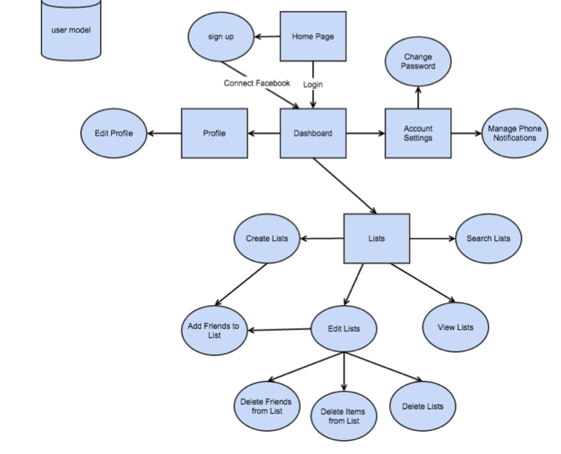

## Screenshots

**LogIn Screen**

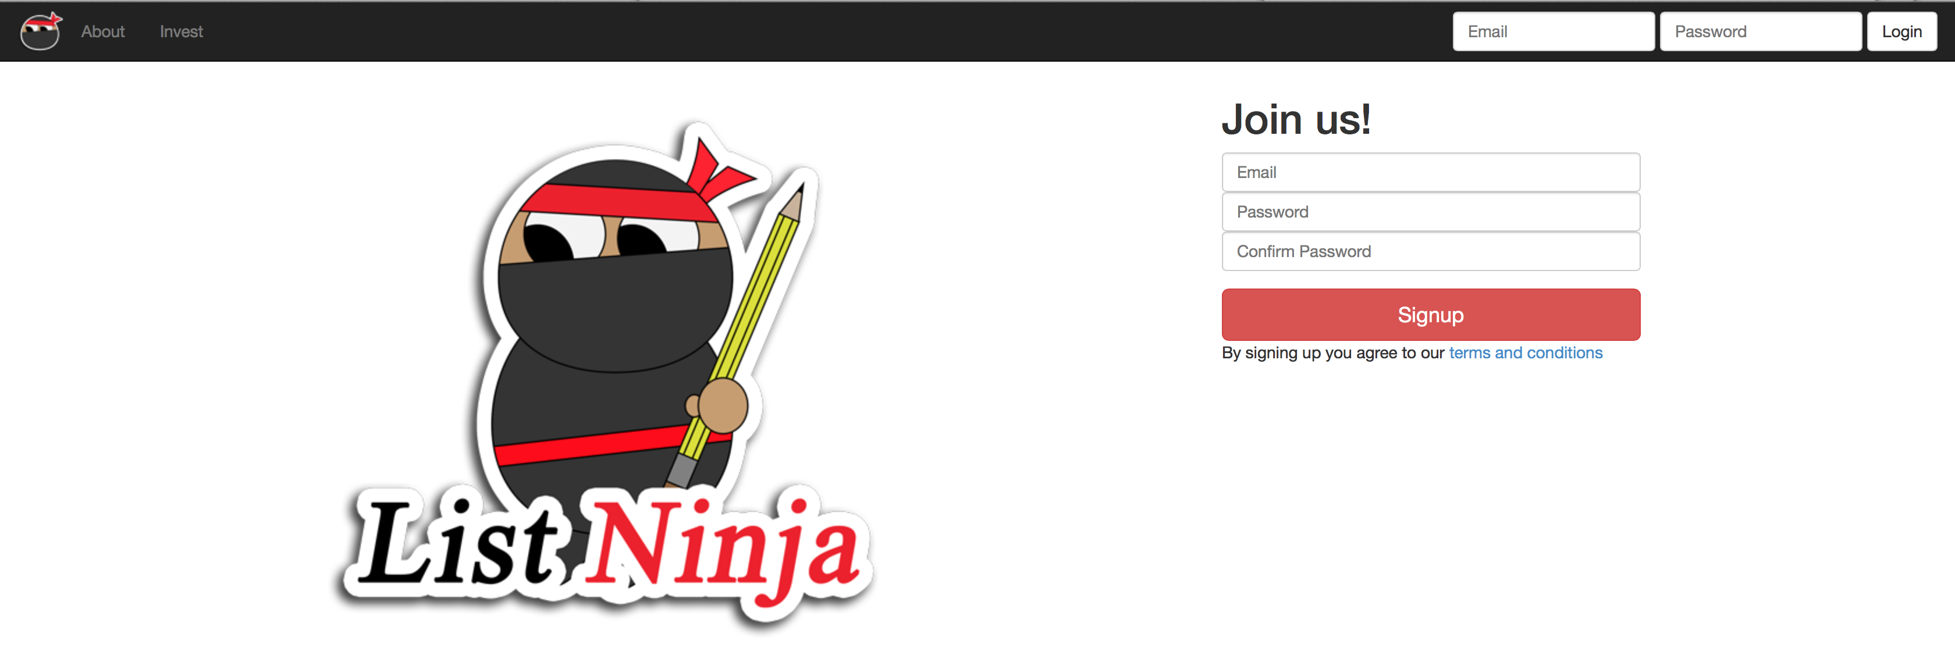

**Homescreen – Most Recent List**

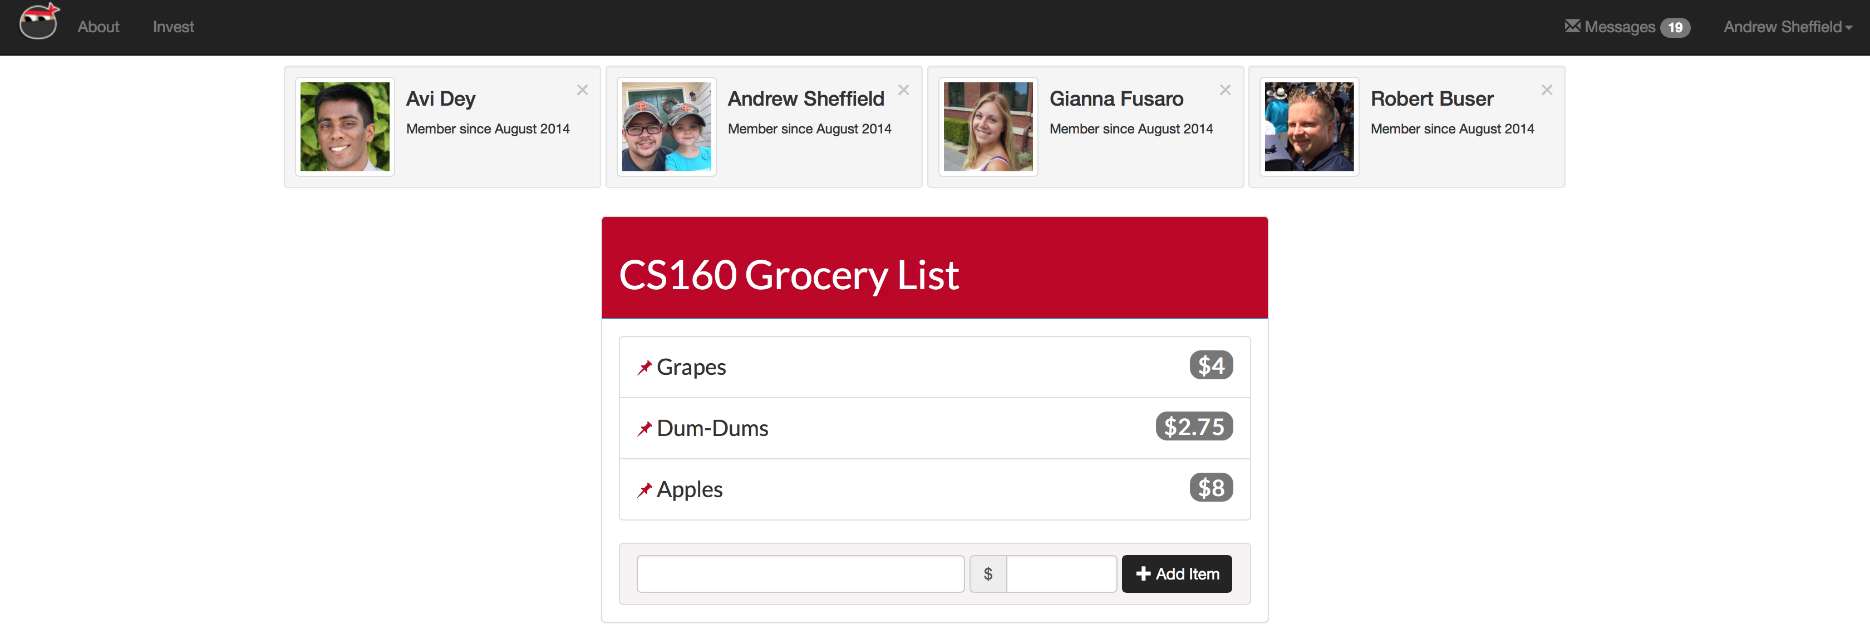

**Editing a List Name**

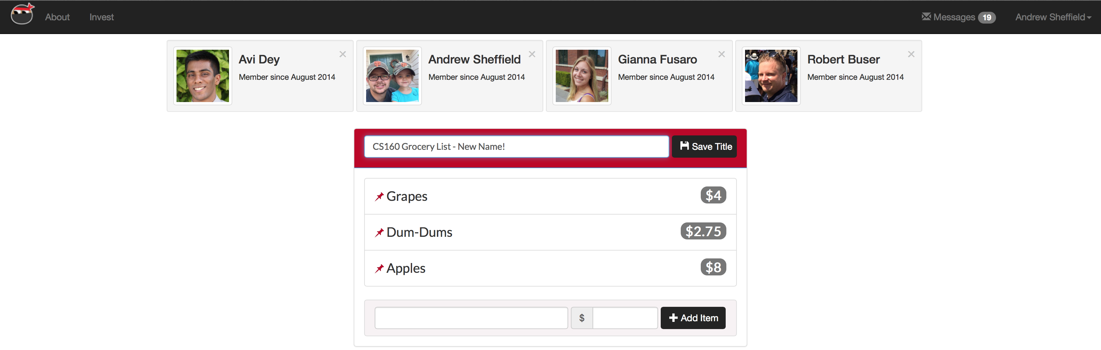

**Editing an item**

